Project Plan:

Schedule:

Let’s try to have people in the lab during these times.

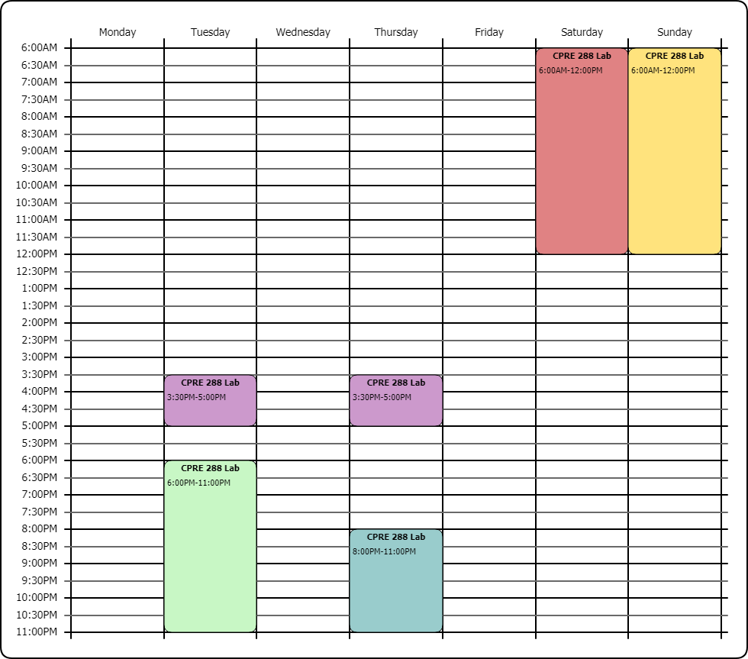

Goal:

The goal is to have a fully autonomous roomba. The roomba must be able to navigate amongst a maze detecting obstacles, holes, and boundaries to arrive at the designated zone.

Approach:

Initially we need to make sure we have all of the sensors that will be utilized in the final project. Develop some sort of algorithm or path detection for the roomba to navigate to the zone using these sensors. If autonomy doesn’t work then the back up plan is to do remote controls, at the expense of extra credit. Search for the thin pillars because they represent the final destination. Once passing within the boundaries you are done.

IDEAS:

Search for the four pillars that mark the destination with a square, white, ‘platform’.

Keep track of objects in certain area and place them in a 2D array.

Robot has to be able to know how long it is and know that it is clear to move without turning away from objects.

Move away from boundaries, towards heavier concentration of obstacles to try to find the 4 pillars. **The four pillars are the only pillars with the thin width.** Once finding one of the thin pillars, essentially you find the final destination place.

Measurements:

Robot: ~34 cm

Thin Pillars: 5.5 - 6 cm

Large Pillars (open): ~12 cm

Large Pillars (closed): ~13 cm

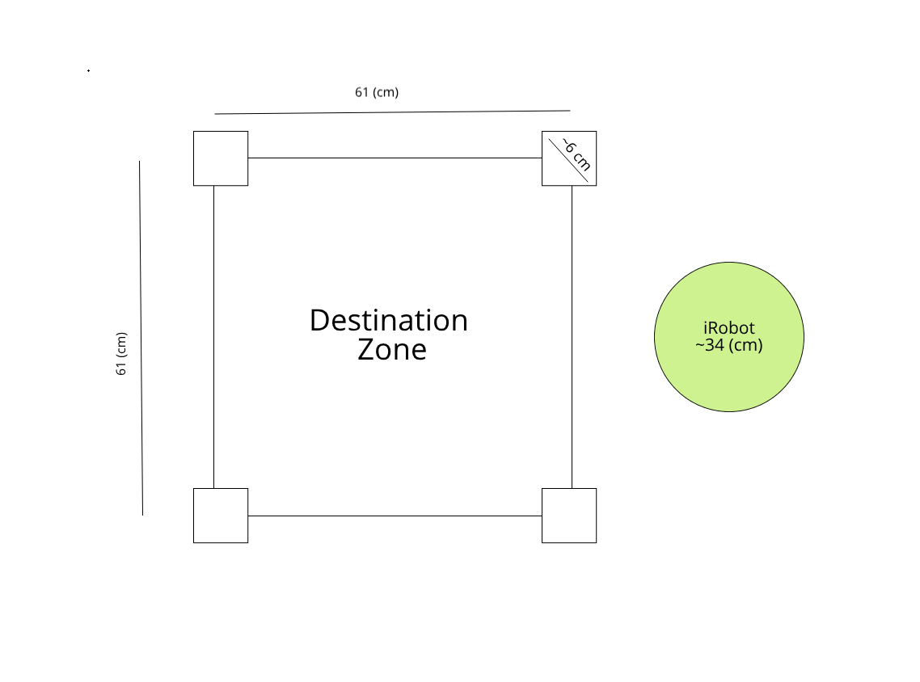

Steps: (2 Week Schedule)

1. Cliff Sensor Finished
2. Test cliff sensor
3. Brainstorm algorithm for detecting destination and see if it could actually work for autonomous robots to find the destination.
4. Make sure each sensor is working accurately. **Test them ALL. (**This is something that can be done very easily in small group sessions. )
5. Develop implementation of the sensors into a main function
6. Start testing implementations of code
7. Field testing with objects and destinations
8. Final project due April 30th , 2019

BOT CALIBRATIONS:

Bot #6

Servo:

310500 + (-158.33333) * degrees

if (degrees >= 180)

{

pulse_period = 282000;

}

else if (degrees <= 0)

{

pulse_period = 310500;

}

IR:

y = 16116x^(-0.792)

Pirates of the caribbean Medley:

{57, 60, 62, 62, 62, 64 ,65, 65, 65, 67, 64, 64, 62, 60 , 60, 62, 30 , 57, 60 , 62, 62, 62, 64 , 65, 65, 65, 67, 64, 64, 62, 60, 62, 30, 57, 60, 62, 62, 62, 65, 67, 67, 67, 69, 70, 70, 69, 67 , 69 , 62, 62, 30 , 62, 64 , 65, 65, 67 , 69, 62, 62, 62, 65, 64, 64, 65, 62, 64, 30}

{8, 8, 16,16,8,8, 16, 16, 8 , 8 , 16, 16, 8 , 8 , 16, 8, 8 , 8, 8 , 16, 16, 8, 8 , 16 ,16 , 8 ,8, 16, 16, 8, 8, 24, 8, 8, 8 , 16, 16, 8, 8, 16 ,16, 8, 8, 16 ,16, 8, 8, 16, 8, 8, 8, 8 , 16, 16, 16, 8, 16, 8 ,8, 8 , 16, 16, 8, 8, 24}

Bot Controls:

‘X’ - Start character

‘M’ - Manual mode